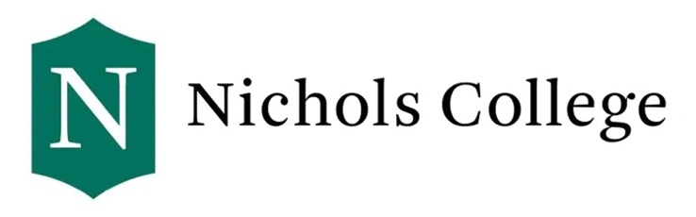
Nichols College

SEVIS Transfer-In Form

Student Instructions: If you are a newly accepted student at Nichols, and you have an active F1 or J1 SEVIS record you would like to transfer to Nichols, please fill out the top part of the form. Once complete, submit the form to your current international student advisor, and work with your current advisor to decide on a transfer-out date. Your advisor should complete the bottom part of the form and give the form back to you. Once complete, new undergraduate students can email the form to IP@nichols.edu.

Advisors Instructions: Please note that Nichols College does not accept terminated or completed SEVIS records. If you have questions, please contact us at IP@nichols.edu .

Student: Please complete the following information. Name should be exactly as it appears on your passport.
LAST Name (Surname): First Name (Given Name):

Date of Birth (MM/DD/YYYY): Email Address:

Nichols Student ID Number: Anticipated Nichols Start Date (MM/YYYY):

Current US Address:

Advisor: Please complete the following information and give it back to the student. Signature should be original. Student’s Current SEVIS Status: SEVIS ID Number: SEVIS Transfer-Out Date: Type of Visa: F1
Is the student pursuing a full course of study? : Yes No

Current Level of Study:

Date of Graduation or Completion/Termination of Study:

Please list any periods of Practical Training or Academic Training:

Name and Title of P/DSO completing this form:

Institution Name: School SEVIS Code:

Institution Address:

Email Address: Phone Number:

P/DSO or A/RO Signature: Date (MM/DD/YYYY):

Nichols’s SEVIS F1 School Code is BOS214F00255000
Office of International Programs • 121 Center Road, Dudley, MA 01571 508-213-2232 (P) • IP@nichols.edu
Revised 07/2023

